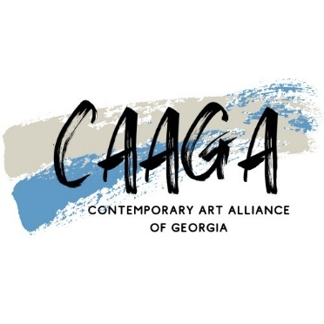

CONTEMPORARY ART ALLIANCE OF GEORGIA

where abstract is the focus
Nina Perry Cahill +1 (203)520-7219, nina@ninaperrycahill.com, www.ninaperrycahill.com

  - 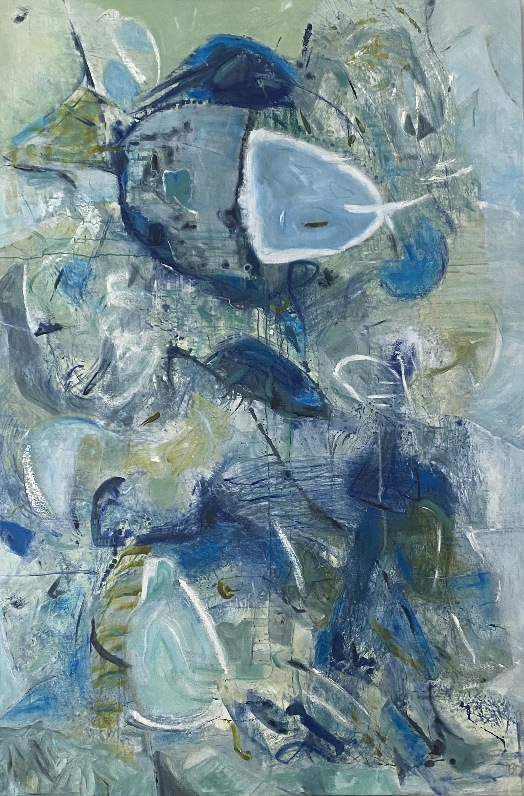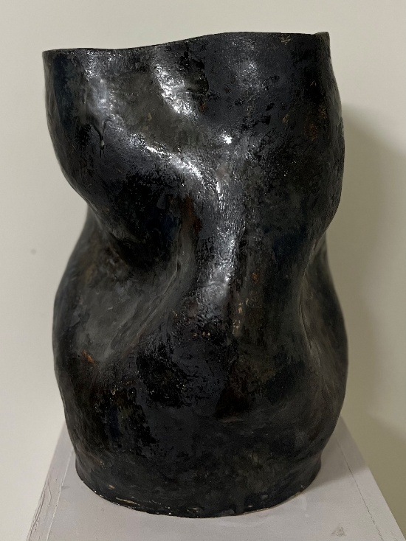
  - Grand Gestures No 1, mixed media, 72 x 48”, Bettina D Rusher Abstract Vessel No 4, glazed ceramic Patricia Crowl
CAAGA is a vibrant arts organization where contemporary and abstract art is encouraged and celebrated. CAAGA was founded by artist and entrepreneur Bettina Dickson Rusher in 2023. CAAGA is now a 501c3 non-profit entity.

Introducing CAAGA:
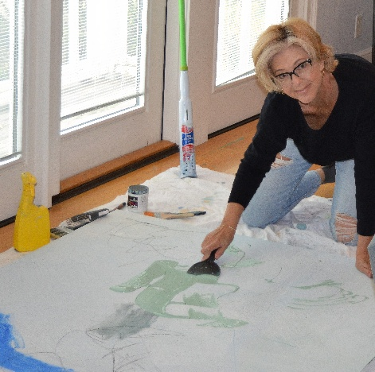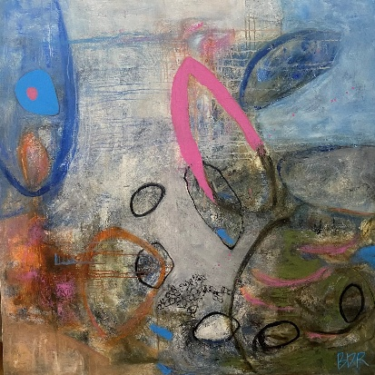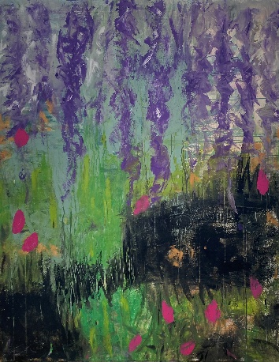

BETTINA DICKSON RUSHER- Sustaining Member & CAAGA Founder

Bettina has an innate need to create. She began painting and drawing at the tender age of six. Bettina loves the journey of the artistic process. Her process goes like this…she begins most canvases with layers of color that are improvised, abstract and even chaotic. Bettina strives to create some amount of push / pull plus lost and found in her edges. Her edges can appear muted where color overlaps and the underlying mark may remain slightly visible. She also has concerns for brushwork and mark making which she uses a variety of tools to create. This can affect the mood, movement, and energy of the piece. Through a process of addition and subtraction Bettina brings each painting closer to balance with sensitivity and attention to detail. Her paintings can have as many as eight layers with transparency to create depth.
Bettina received a BA in Art & Design from Eastern Kentucky University in 1984. Bettina's education at EKU included a minor in Business. She continued her art education in San Francisco from 1991- 1994 at the San Francisco Art Institute.
Bettina’s art can be found in private collections in Arizona, California, Florida, Georgia, Kentucky, North Carolina, Ohio, South Carolina, Tennessee, Virginia, Wyoming and Germany. Her corporate/ institutional clients include Oracle in San Francisco, San Diego, Seattle Washington, and The University of Kentucky in Lexington Kentucky.
Bettina welcomes the opportunity to design and implement commissioned pieces for homes and corporate spaces.
……………………………………………………………………………………………………………………………………………….
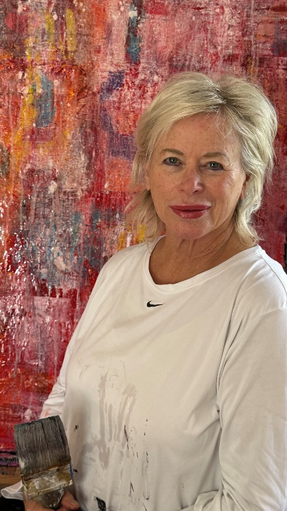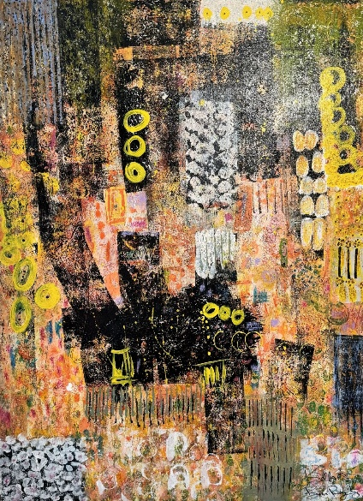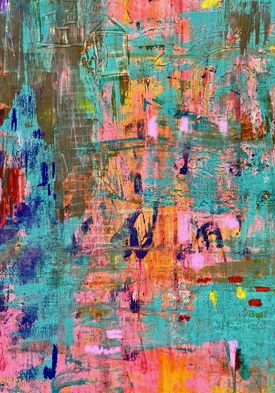
________________________________________________________________________
BONI RAY- Sustaining Member

Boni Ray began her journey into abstract art following her retirement in 2021 from a thirty year career in Aesthetics. Taking a leap of faith she embraced her newfound passion wholeheartedly and embarked on a journey of abstract self-discovery into the realm of painting.
Each brushstroke becomes a dance of vibrant color, layers, textures, and form. With every blank canvas, her art transforms into a visual symphony, echoing the essence of her soul. Each piece she creates narrates a story of resilience, passion and the unwavering spirit of an artist finding new purpose.
Retirement lets Boni Ray fully immerse herself in continuing education in all forms of abstract and contemporary art. Her excitement continues to burgeon as she progresses in her journey of abstract exploration and personal growth.
……………………………………………………………………………………………………………………………………………….
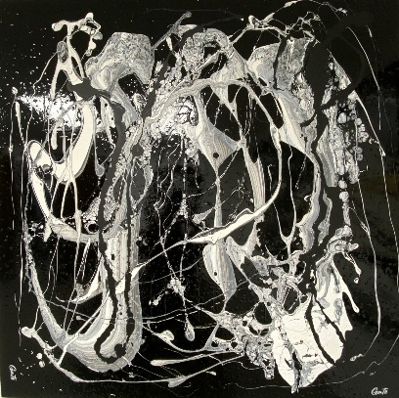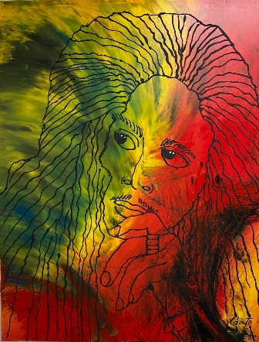

GATO- Sustaining Member

Gato, aka Gary Grace was born in Pittsburgh, PA at a time when Steel town blast furnaces were still ablaze, the scent of coke and soot dominating the city. As a child, he rode his bicycle through busy streets from one corner of the city to the other, exploring fearlessly at such a tender age, the thought would make any mother quiver. It is his quest to blend form with nature and his innate ability to visualize abstract concepts that are the foundation of his highly revered art style “Industrial Abstract.”
Gary attended the Art Institute of Pittsburgh where he majored in fashion illustration and clothing design where he was able to refine his style and learn valuable techniques that he utilizes in his artwork today. He learned to work with Chalks, Crayons, Rapidograph Pens, Inks, and Watercolors and was cross enrolled in Clarissa School of Fashion Design where he learned to make patterns and sew. He made the dean’s list three times and was featured in showcases for his work with ebony pencils, ink, and technical pens. Gary is the founder of the clothing line “Posse,” which went national in the 1980s.
Abstract Oil is the medium that Gary loves and is the most well-known for, however, he is a very well-rounded artist, his travels have brought him an affinity for landscape photography, and he has written and Illustrated a published children’s book, “Sasha, I Can’t Find My Bicycle.” Gary is currently working on two adventure novels’, “45” and “Throwbacks,” he is a songwriter and has been playing the drums since age 11.
……………………………………………………………………………………………………………………………………………….
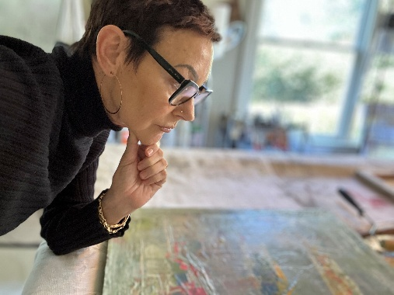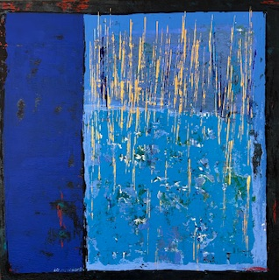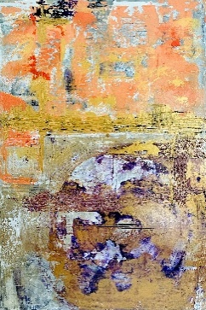

HILARY KENT- Sustaining Member

"I see texture as peaceful and loud at the same time."
Hilary Kent is a native New Yorker and St. Simons Island based artist specializing in archival acrylic on canvas and mixed media.
Hilary’s interior design background in New York City and Boston trained her to create structurally while being fluid and bold with concepts and vision. Her work radiates a myriad of colors, layers and textures, creating sophisticated pieces of abstract art.
Hilary Kent’s work can be viewed in galleries and private collections.
Hilary is a member of Glynn Visual Arts (GVA) on St. Simons Island, GA.
……………………………………………………………………………………………………………………………………………….

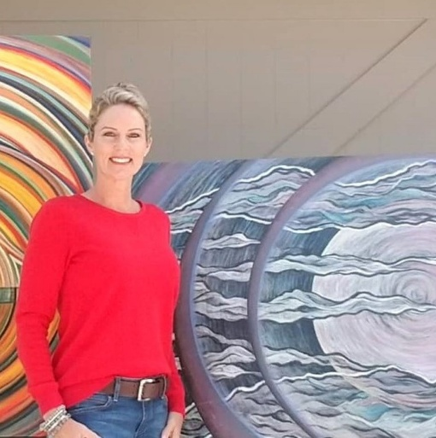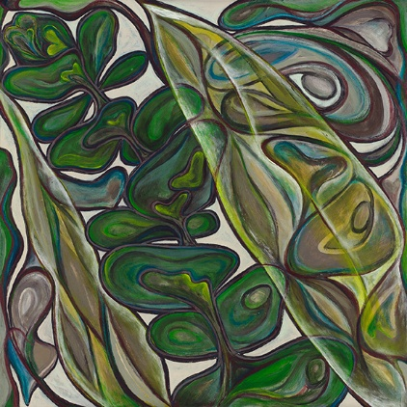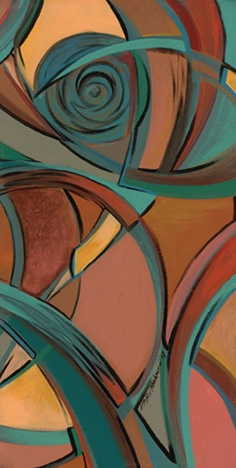

KIM P. BARTHOLOMEW- Sustaining Member

Kim P. Bartholomew is an abstract artist residing in St. Simons Island, Ga. Kim earned a Bachelor of Science degree in Art Education and a Master of Science degree in Counseling Psychology & a Specialist of Education in School Counseling. She spent 15 years of her career in these disciplines. Kim has merged her passions and launched a path of creating her own works of art as a form of therapy for the soul – for herself and the viewers.
As an abstract artist, her work in steeped in patterns of stylized silhouettes, curvilinear visual rhythm, and symbolic (rather than realistic) colors and shapes. She works in a variety of media creating series of themes to express what is felt beyond what is seen.
Original works, commissioned pieces, giclée's, prints, cards, and related products displaying Kim’s art can be observed and obtained through Kim's website, social media outlets, and at local exhibits. A portion of all Kim’s art sales is donated to Florida School for the Deaf and the Blind (www.fsdb.k12.fl.us) where her niece attends school in St. Augustine Florida.
……………………………………………………………………………………………………………………………………………….
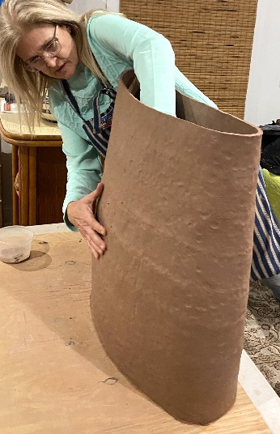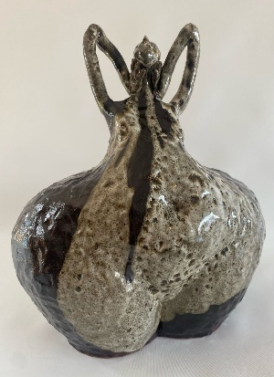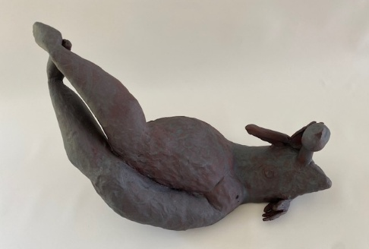

LINDA BOBINGER- Sustaining Member

Linda taught in the Camden County school system in Georgia earned both a master’s in art education and master’s in fine arts focusing on ceramics from Georgia Southern University in Statesboro Georgia. After thirty-one years of teaching, she presently lives in Darien, Georgia, where she continues to focus on ceramic sculpture.
Linda Bobinger's artistry transcends time, opening a window into her creative evolution from the past to the present. A defining characteristic of her work is the seamless progression of influences from her earlier sculptures to her current creations. Central to her artistic exploration, her work has been the enduring inspiration drawn from Henri Matisse's timeless masterpiece, "The Joy of Life." Renowned for his vibrant compositions and expressive use of color, Matisse's paintings have served as a muse for Bobinger throughout her career. Particularly resonant are Matisse's depictions of female figures, which have captivated Bobinger's imagination and found expression in her sculptures. Embracing Matisse's philosophy of simplifying form into essential lines and shapes, Bobinger's work exudes a sense of vitality and exuberance.
……………………………………………………………………………………………………………………………………………….
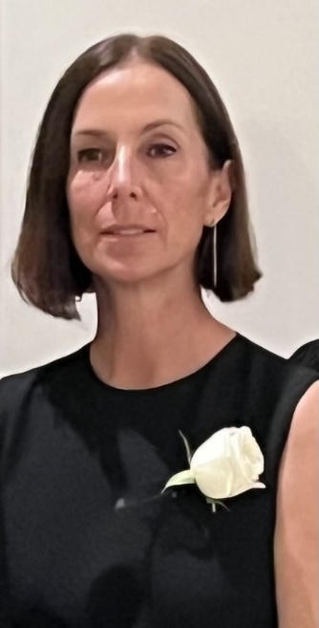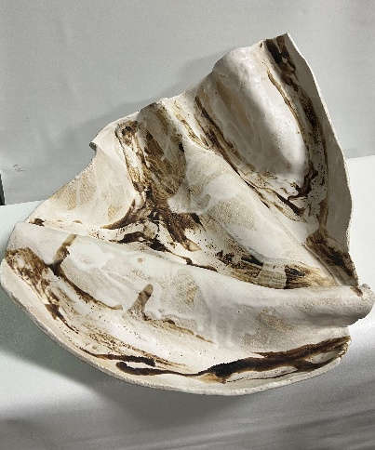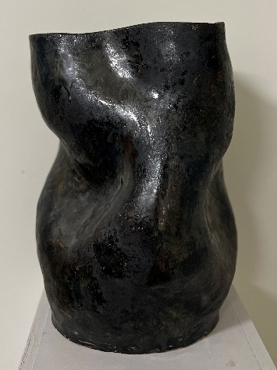

PATRICIA CROWL- Sustaining Member
Patricia is intrigued by the organic shapes and lines encountered daily and incorporates these into her work. She has used a wide array of mediums during her artistic journey, beginning with fabric, followed by paint, and most recently clay. She finds clay to be seductive and unpredictable, qualities which continually intrigue her. Her vessels and objects are raw, untamed quality, and no two ever alike.
Patricia strives to build compositions that feel authentic and natural, but also modern and organic. The challenge of creating objects that are uncommon, and novels always excite and entices her. The highs and lows experienced during the evolution of a piece are both exciting and invigorating, and the thought that the work may resonate with someone, absolutely thrilling.
……………………………………………………………………………………………………………………………………………….
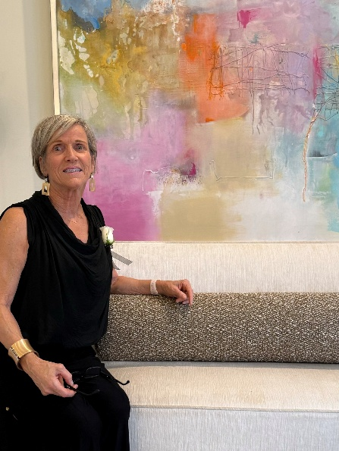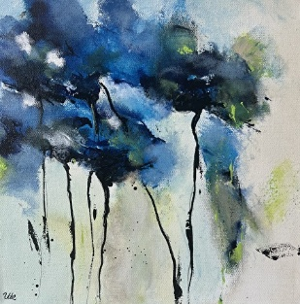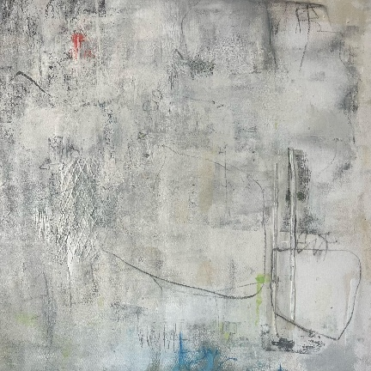
________________________________________________________________________
UTE KLEEMANN – Sustaining Member
Ute is a German-born abstract, mixed media artist and collagist. She began painting as a young girl, and art has become a vital part of her life for nourishment, healing, and connecting with her intuition. Ute aims to deliver not only a final painting but also the experience she undergoes during the creative process. Her art focuses on colorful impressions and modern interpretations of idyllic landscapes. Ute primarily works on canvas, combining acrylic paint, oil pastel, watercolor, ink, sand, cement, and collage layers. Her art fascinates bright colors and their interactions with textural scenes and concepts. Ute settled permanently on St. Simons Island in 2015.
…………………………………………………………………………………………………………………………….
CAAGA ASSOCIATE MEMBERS
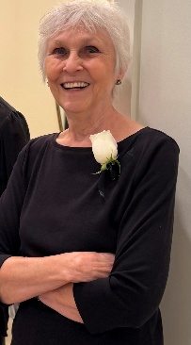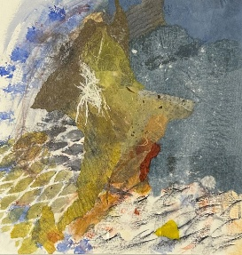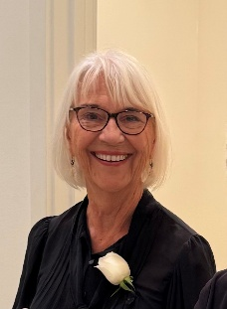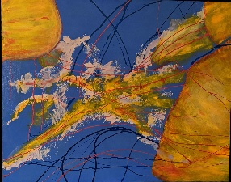
Pam Brannen, Collage Artist Suzanne Scaglione, Painter

